Free Second-Hand Clothing Distribution System
System Request and Feasibility Study / Planning Phase
(Homework No.1B)

Project team: Team 02
Instructor: Dr. Araz Yusubov

Submitted in partial fulfillment of the requirements of the INFT 2303: Systems Analysis and Design course project

GitHub repository | https://github.com/ADA-SITE-INFT2303-2023-Spring/<name of the repository>
Version date | Version information
21.02.2023 | Initial draft
05.04.2023 | Final version of the Project

Team member | Contribution to this homework (NOT the project) | Estimated %
Atlas Hamzali | Introduction, Overall Description, Business Value, Tangible/Intangible Benefits, Special issues or constraints, Constraints, Economic Feasibility, Commits on GitHub | 25%
Nargiz Heybatova | Business Need, Business Value, Tangible/ Intangible Benefits, Factors that affect System’s Requirements, User Characteristics, Assumptions and Dependencies, Research | 25%
Farid Mammadli | Definitions, Business Requirements, Product Perspective, Product Functions, Technical Feasibility. | 25%
Azer Shukurlu | Organizational feasibility, Economic feasibility, Product Perspective, Research | 25%

Table of Contents

Table of Contents 3
1. Introduction 3
Definitions 4
2. Overall Description 6
Product Perspective 9
Product Functions 10
User Characteristics 12
Assumptions and Dependencies 13
3. Feasibility Analysis 14
4. References 16

Introduction
This is part of the System Proposal for a hypothetical project “Free Second-Hand Clothing Distribution System” submitted for partial fulfillment of the requirements of the Systems Analysis and Design course in the School of Information Technologies and Engineering at ADA University, Baku, Azerbaijan.

Starbucks App - Farid Mammadli
- The project has been initiated to create some opportunities for the customers to make the purchasing and other customer related operations over the internet using the software. This system is also aimed to help the business to have an antagonistic position in the Azerbaijan market by increasing the sales growth.
PasientAZE - Atlas Hamzali
- This is an information system that will allow users of any device to get health-related information leading to effective healthcare and increasing patient satisfaction. Personal health information will be available 24/7 from any location with access to the Internet.
CyberTest - Nargiz Heybatova
- The application provides a virtual representation of real high-security governmental, organizational, and corporate websites in Azerbaijan. Candidates can join the application to find vulnerabilities and submit reports to receive special rewards. Data of candidates' actions is collected for analysis to identify common trends in hackers' behavior.
Online Parking Reservation - Azer Shukurlu
- This system is created to make it easy to find and reserve a parking place for a car or any vehicle in online format with the help of a website or application before reaching there.
One of the main reasons we did not choose the patientAZE system was that we realized another team had a similar system. As a result, we did not prefer this system and focused on other systems in the team.
Secondly, we did not go with " Online Parking Reservation”, because some users might prefer the traditional form of parking and be hesitant about adopting an online system. This can reduce the number of users and slow down the new system.
Thirdly, we did not choose the “CyberTest” system because implementation of the CyberTest system may need significant time, money, and resource commitment.\ Finally, the "Starbucks App" system remained, and this system also had some problems like the above systems, which the system name should be fixed, and since this is not a very common problem in Azerbaijan, the system should be completely changed, and some functions added, some had to be removed. Finally, we concluded that changing and making the system more dependent on donations could be more useful in solving many problems in Azerbaijan.
Size scope: A free second-hand clothing distribution system's size and scope can differ greatly according to the location and population it supplies. It might range from a small neighborhood activity to a huge national or indeed worldwide enterprise.
Cost: The cost of setting up and building a free second-hand clothing distribution system varies according to the program's size and scope. Personnel, delivery, storing, and selecting donated clothing can be added to expenses.
Purpose: A free second-hand clothing distribution system's goal is to supply clothing to people who are not able to buy new clothing, to reduce the need for new clothing, and to minimize the negative environmental effect of the fashion business.
Length: A free second-hand clothing distribution system should generally be in place for as long as there is a demand in the community.
Risk: A free second-hand clothing distribution system has a number of risks. One risk is that the clothes will be of low quality or inappropriate for the regional environment and cultural standards. Additionally, the system would promote a mindset of dependency and harm local enterprises. Furthermore, there could be several difficulties in gathering, organizing, and delivering the clothes.
Impact Scope: A free second-hand clothing distribution system would have a huge effect since it would effectively help individuals and families who are not able to buy new clothes. It may also have greater environmental effects by minimizing the need for clothes and waste of clothes.
Economic Value: The economic value of a free second-hand clothing distribution system would be mostly derived from the cost savings experienced by individuals and families who get free clothing. It may also lead to reduced expenses for the government or other groups that offer clothes support programs. Also, it may help to reduce the environmental expenses connected with the clothing business. Nevertheless, establishing and maintaining the system would need tremendous investment and resources.

Definitions

Term | Definition
CSR activities  User base  Data Volume  HTML  CSS  Scripting language  JavaScript  Client-Side Scripting  Library  React language  Open Source  Relational Database  MySQL  Server-side scripting  GPS  Protocols Encryption  SSL  ROI  BEP | Corporate Social Responsibility (CSR) activities are self-regulated actions that a business can take to be more socially accountable to its stakeholders and the public in general.  Number of the users who use any application.  Amount of data that is stored and used by a system.  Hypertext Markup Language which creates the structure content for the web page  Cascading Style Sheets is a stylesheet language which is used to style the structure of the web page.  Enables a high-level construct which helps to interpret and execute a command at a time.  A Scripting language that creates an opportunity to create dynamic contents on a website.  Helps to run scripts (for ex JavaScript) on the client’s device (usually in a browser)  Collection of prewritten code that programmers use for the optimization of the tasks.  A JavaScript Library for building user interfaces  Software in which the original source code is freely available for everyone and can be distributed.  Collection of information in relationships where data is stored in one or more tables of columns.  Open-source relational database management system to store and retrieve data.  Execution of scripts on a web server to generate dynamic web pages.  Global Positioning System that provides positioning, navigation, and timing information  Set of rules that describes the procedures for transmission of data converting human-readable plaintext into incomprehensible text for protecting data.  Secure Sockets Layer (SSL) is a security technology for establishing an encryption between a server and a client.  Return on Investment computes a percentage comparison between an investment's cost and net profit.  Break-Even Point, at which a company's total revenue equals its entire expense.

Overall Description

The "Free Second-Hand Clothing Distribution System" is an information technology system that intends to distribute free second-hand clothing to individuals or families who are in need via online platformPeople, companies, and organizations will be able to donate second-hand clothes through the system. The system will necessitate the collection of second-hand clothing, its categorization, and delivery to specified locations. Donations will be checked and categorized according to size, season, and gender. The system will also contain user registration and verification process, inventory control, and analysis and reporting features. The objective of this system is to provide an effective platform for the coordination of second-hand clothes contributions. The technology will simplify the process, making it simple for individuals, businesses, and organizations to use it. The method will also guarantee that donated clothing is correctly categorized and arranged and it will make it easier to deliver the clothes to individuals in need. The Free Second-Hand Clothing Distribution System's purpose is to develop an environmentally friendly and effective method of distributing second-hand clothing to people and their families in need. The system will assist to eliminate poverty and encourage sustainable fashion techniques by making it simple for people to give and for people in need to receive free clothes. In conclusion, this system is an IT system that may provide a variety of profits, goals, and objectives, such as distributing free clothing and alleviating poverty.
- Business need
The need for the Second-Hand Clothing Distribution System is supported by several sources. According to research article by Etibar Gahramanov and Aytaj Badalova, Azerbaijan is facing a significant challenge in managing waste, including clothing waste. The article notes that clothing waste is often discarded rather than donated or recycled, leading to environmental pollution. The lack of access to clothing is also highlighted in a report by the Baku Research Institute, which notes that poverty and unemployment in Azerbaijan are significant issues that contribute to a lack of access to necessities, including clothing.
The Second-Hand Clothing Stations system addresses these issues by providing free second-hand clothes to people in need through designated stations across the city. The system aligns with the World Bank's recommendation to manage waste safely, including promoting the reuse of materials, such as clothing. The system also supports the Tamiz Shahar project by promoting environmental sustainability and reducing waste pollution.
Furthermore, the system is in line with Azerbaijan's 2030 vision, as outlined by the Baku Research Institute, which includes goals to improve social welfare and reduce poverty. By providing free clothing to those in need, the system helps to address some of the challenges related to poverty and lack of access to basic necessities.

- Business requirements
- Box Containers Management: Displays the addresses of the containers on the
system, and keep track of their inventory.
- Clothing Categorisation: List all the clothes and the id of the particular
container that holds the specified clothing.
- Search Functionality: Users will be able to search for the desired clothes (type, size, gender, etc) and display their location on the map.
- Donation Adding: Users will upload their clothing information and the pictures to the system.
- Donation Details Editing/Deleting: There will be a possibility for the users to edit or delete their clothes information on the system if there is something mistyped or missed. There will also be verification that all information provided for the donation is approved.
- Donation Removing from the Container: The clothes that are defined as useless by the rules of the system will be removed from the container’s inventory and the system at the same time. However, unauthorized users will not be able to remove others’ donations.
- Donation Taking by the Users: The users who will take the clothes out of the containers will be able to warn the system which will result in the drop of the related donation information from the container inventory and the system.

- Maintenance and Support: Users will be able to report any issue related to the system and the container boxes to the administration to get help on a particular problem. Customer support will forward the report and the administration team will accept the request.

- Business value
The Free Second-Hand Clothing Distribution System offers significant business value to the city of Baku, Azerbaijan. First, it contributes to the development of a sustainable environment by reducing clothing waste pollution. The system provides a sustainable solution to the problem of clothing waste, as it encourages people to donate their second-hand clothes rather than discarding them. This, in turn, reduces the amount of textile waste generated, thereby reducing the environmental impact of the fashion industry.
Second, the system addresses the issue of lack of access to clothing, which is a crucial need for people in poverty and facing unemployment. By providing free clothing, the system can contribute to improving the lives of disadvantaged people in the community, enhancing their dignity and social welfare. According to a study by the European Commission, access to affordable clothing is an essential aspect of social inclusion. Therefore, the Free Second-Hand Clothing Distribution System has the potential to reduce clothing poverty and promote social inclusion in Baku.
Finally, the Free Second-Hand Clothing Distribution System provides an opportunity for businesses and organizations to engage in corporate social responsibility (CSR) activities. According to a study by the Harvard Business Review Companies that engage in CSR activities can benefit from improved brand image and reputation, increased customer loyalty, and improved financial performance. Therefore, businesses that participate in the Free Second-Hand Clothing Distribution System can benefit from positive brand association and increased customer loyalty.

Tangible Benefits:
- Improving Financial Situation: By helping people who cannot afford to buy new clothes the system will decrease the financial pressure on these families and let them spend money on other necessities such as food, accommodation, healthcare, and education.
- Reducing Waste Disposal Costs: A free second-hand clothing distribution system can increase production efficiency and lower waste disposal costs by minimizing clothing waste.
- Making Profit: Several organizations' advertisements will appear on our platform, and by promoting their product, service, or event we will profit from it.
- Improved Data Management: The system enables the efficient management of clothing donations and inventories, reducing the risk of errors and improving accuracy.

Intangible Benefits:
- High Respect: Users, employees, and other partners may see businesses devoted to social and environmental sustainability more warmly. Companies may express their dedication to decrease waste and minimizing environmental impact by adopting free second-hand goods.
- Greater Consumer Trust: Users are more inclined to stick with a company that is dedicated to social and environmental responsibility. Organizations may leave an outstanding mark on clients and strengthen their loyalty by giving free second-hand clothes.
- Improved Image: The system can enhance the image of the city by promoting a culture of sustainability and social responsibility, making it a more attractive place to live, work, and visit.
- Environmental Benefits: The system promotes environmental sustainability by reducing textile waste and promoting the reuse of clothes, which can have a positive impact on the environment. This leads to increased awareness of environmental issues and sustainable living practices.

- Special issues or constraints
- Quality: The quality of used clothes might differ, and there may be issues regarding the condition of the clothing being provided. It is critical that the clothing given be hygienic, comfortable, and in decent form.
- Stock Control: Maintaining a big stock of donated goods may be difficult. Choosing, categorizing, and keeping goods in an efficient way may be necessary.
- Cultural Knowledge: Clothes may be a significant cultural symbol, and there might be cultural concerns when donating used clothing. It is essential to consider the target receivers' cultural choices.

- Environmentally friendly: The distribution of secondhand goods may be an essential element of a sustainable system. Yet, there could be potential environmental risks associated with the delivery, maintenance, and removal of non-distributable goods.
- Compliance with applicable laws and rules: The system must abide by all applicable laws, as well as those governing data security and those governing the transmission and disposal of clothes.
- Safety and confidentiality: The system will have to deal with critical user data, therefore it should guarantee that the information remains safe and confidential.

The success of the Free Second-Hand Clothing Distribution System will depend on several factors that will affect the system's requirements. One of the most important factors is the availability and quality of second-hand clothes. The collection, sorting, and quality control of second-hand clothes requires dedicated staff to ensure that the clothes are in good condition and clean.
The user registration process will also be a critical factor in the system's success. The system must have an easy-to-use registration process that collects essential information like name, address, and contact information from users who need the clothes. The registration process must be easy to use and accessible to everyone, including those who cannot access the internet. The system must also ensure that user information is kept confidential and secure. Additionally, the system must provide adequate communication and support channels for users who may have questions or issues while using the service.
Another important factor is the designated stations for clothes distribution. The stations must be easily accessible to users in need and must be in areas where there is a high demand for second-hand clothes. Also, the Free Second-Hand Clothing Distribution system must also have a reliable method of verifying the eligibility of users to receive free clothes, ensuring that the resources go to people who genuinely need them.
Thissystem's sustainability will also be a factor that affects its requirements. The system must be designed in a way that is environmentally sustainable, and the process of collecting, sorting, and distributing second-hand clothes must be done in a way that does not harm the environment. The system's sustainability depends on securing adequate funding to cover the costs of collecting, sorting, and distributing the clothes, as well as maintaining the infrastructure and staff required to run the service.
Finally, the system's success will depend on the community's support and participation. The success of the system will depend on the willingness of the community to donate clothes, volunteer their time to sort and distribute clothes, and register to receive free clothes.
The system must have a reliable distribution network that ensures that clothes are delivered to designated stations in a timely and efficient manner.

Product Perspective
"Free Secondhand Clothing Distribution System" is a product that provides a possibility for people to get secondhand clothing freely and reduce waste. In a marketplace, there are some products which can be related to the system:
  - Freecycle (https://www.freecycle.org/pages/about) - a nonprofit organization that promotes the recycling of the products. This process is done by connecting users who want to share their products they no longer need with the other users who need them. The product idea is much more like our product. Both are the nonprofit organizations that prevent waste and consider the people who need a product. The main difference between the products is that “Free Second-hand Clothing Distribution System” only focuses especially on clothing when “Freecycle” provides every item people can give away. Another difference is that the “Freecycle” does not provide an online service for the people to share their needs or donate and all the processes are done on a network of local groups.
  - ThredUp (https://www.thredup.com/): The project provides an online thrift store for people to buy and sell second-hand clothes. The similarity for both products is that they create a network for people to easily fulfill their clothing needs by searching online and donating if they do not need any of their clothes. One of the differences is that ThreadUp is a for-profit organization where people can only sell or buy second-hand clothes.

The diagram is also provided in ZIP folder:

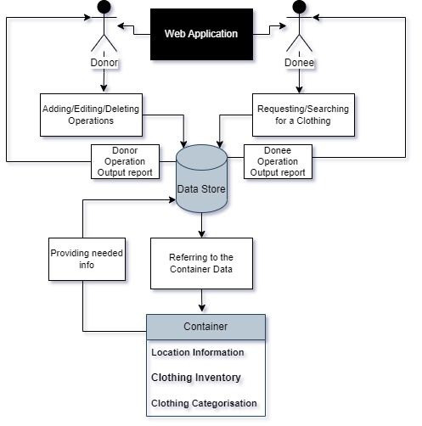

Product Functions
- User Registration and Authentication Interface: Users will be able to register themselves by providing their id card and phone number information to the system. They will get access to use the system once the registration is approved by the administration.
- User Guide & Training: The training will help the people to get familiar with the user interface and how the system works. This will be conducted by the offline user manual book and the instructive slides describing the steps on a related process.
- Search Panel: Some criteria will be available for the users to search for the desired clothes (type, size, gender, etc) and display the details of related containers that have the specified clothing.

- Donation Adding: Users will upload their clothes information and the pictures on the system by specifying the referenced container box id and the category that the donation will be included.
- Donation Post Editing: The product will create a possibility for the users to edit the provided information based on the clothing that they publish on the system. For example, type, size, color, etc.
- Donation Post Dropping: The system will drop the posts about clothing if the donation does not satisfy the rules that are decided by the administration. For example, the clothing may not be in a good condition to donate etc.

- Donation Management: The function will create a history report on each user’s account based on his donations or the clothes that he took from the containers.
- Monthly Report: The system will analyze the user needs monthly to report donors about the most requested clothes.
- Customer Support Senter: Users will be able to report any issue related to the system and the container boxes to the administration to get online help on a particular problem by service.
- Report: Users will be able to provide their feedback to improve the system functionalities and user satisfaction.
- Related Products Advertisements: The system will follow the charity related products ads to display them on the user interface for the people who need them.

The diagram is also provided in ZIP folder:
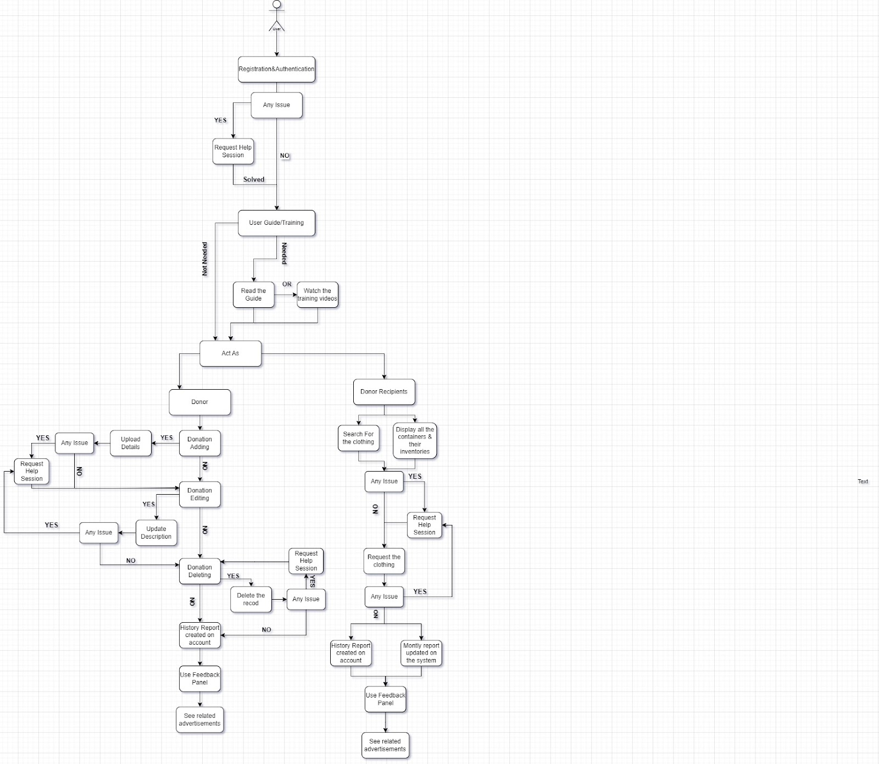

We created a diagram in HW03 which is more detailed and understandable.

User Characteristics
- The intended users of the "Free Second-Hand Clothing Distribution System" are likely to be individuals or families who need clothing assistance due to financial constraints. These users may have a range of educational levels, from high school education to college degrees or beyond. However, their educational level is not likely to be a significant factor in their ability to use the system.
- Experience and comfort with technology will be critical factors in the design of the user interface. The system needs to be user-friendly and intuitive, even for users with minimal experience using computers and browsing the internet. It should be easy for them to navigate through the registration process and find the information they need.
- Users are expected to have basic experience using computers and browsing the internet, having filled out online forms or surveys, and possibly having purchased or sold a product online. They are also expected to have a computer with access to the internet, which implies that the system should be designed to work on a range of devices, including desktops, laptops, tablets, and smartphones.
- Users' willingness to share personal information such as home address and contact information is also essential to the system's success. Therefore, the registration process should be designed to be secure and provide users with assurance that their information will be kept private and confidential.
- In addition to these factors, other user characteristics that may influence the system's design include language preferences, cultural sensitivities, and accessibility requirements. The system should be designed to accommodate users from different linguistic backgrounds and cultural contexts, and it should be accessible to users with disabilities.
- Overall, the system's design should prioritize simplicity, accessibility, and inclusivity to accommodate the diverse needs of the intended users. The user interface should be easy to navigate, instructions should be clear, and the system should be accessible to users with varying levels of technical expertise and diverse backgrounds.

Constraints
- High Cost: The expenses of keeping and handling distribution stations can be expensive, including maintenance, delivery, and employees.
- Failure to satisfy specific requirements: second-hand goods may not always match users' particular needs, such as clothes for the recruitment process or formal events.
- Not Enough Supply: Donated clothes may not be enough, and there could be insufficient supplies to fulfill the demands of all people.
- Lack of Stock Management: Donated clothes supply is determined by what is given, so there could be minimal control over the sizes of clothes that can be given away.

Assumptions and Dependencies
Factors that affect the requirements of the system:
- The number and availability of box containers could affect the number of clothes that can be collected, stored, and distributed by the system.
- Changes in the location of designated stations may require updates to the container box management and search functionality of the system.
- The frequency and quantity of clothing donations could affect the system's inventory and its ability to meet the demands of users.
- Changes in user demand for specific types of clothing may require adjustments to the categorization and inventory management system.
- Decreased number of manpower to manage the collection, sorting, and distribution of second-hand clothes to the designated stations may prevent the system from meeting its goals.
- Changes in user behavior, such as an increase in misuse of the system, may require changes to the donation and inventory management system.
- Availability of technical support and maintenance could affect the system's uptime and reliability. Lack of funding for the maintenance and upkeep of the system, including replacement of container boxes, technology upgrades, and maintenance of the web application may decrease overall efficiency.
- The availability of hardware and software may affect the design and development of the system; therefore, the system settings may need to be adjusted based on the technology available for implementation. The system assumes that the necessary IT hardware will be available to support its operation. Changes in the availability of hardware or differences in hardware configurations can affect the requirements of the system.
- The number of users expected to use the system will affect the design and scalability of the system, as well as the number of collection and distribution points required. The size of the database will be affected by the number of registered users, the number of donations, and the frequency of updates. As the size of the database increases, the requirements of the system may need to be modified to ensure optimal performance.
- Changes in laws or regulations related to clothing donations could affect the system's operation and requirements. The system must comply with any rules and regulations regarding the distribution of second-hand clothing.

Feasibility Analysis
Technical feasibility: can we build it?
The system is achievable to create through different modern technologies such as web development frameworks and database management systems. To develop the project technically, some factors should be considered. For example, the system should be responsive as the user base and data volume increases and it should meet the user needs. Here are some sub points that the project needs to consider in technical aspects:

- Web Application Structure Development: Web application should be developed to create an opportunity for the users to use the functionalities of the system. Firstly, to structure the simple website application for the system, the project needs HTML (Hyper Text Markup Language).
- User Interface Design: The system needs a user-friendly and minimalistic design with interactivity to make website operations easier for the users. Furthemore, the design of the website application should also grab some attention. For that reason, CSS (Cascading Style Sheets), stylesheet language should be used to style the main structure of the website. Furthermore, JavaScript (client-side scripting language) should be used to add interactivity to the web application. To go deeper, React (JavaScript library) is a better option to build a fast and scalable user interface which dynamically updates the page’s content when there is a new operation.
- Database Development: For the web application that includes all the containers inventories and the reports about the users, database management system is a mandatory factor to consider. On that side, MySQL (open source relational database) should be used to store and retrieve data when needed. For interacting with the database and other server side tasks, the system requires PHP (server-side scripting) language.
- Container Tracking System: This side can be achieved by a tracking system which is GPS. It will monitor the location and availability of box containers on the system.
- User Data Security: The system should ensure the user data security (login credentials, personal information, and activity reports on the system). To provide this functionality to the system, SSL (Secure Socket Layer), security protocol should be used. It uses an encryption service for the security which is implemented using C#, Python, Java, and Ruby programming languages.

To conclude, in the development process of the project, the factors listed above should be considered during the technical feasibility analysis. For the user, the familiarity with the application or the technology will be provided by the user manual and the training videos describing the exact steps that should be taken for a particular process. As the project does not provide so many difficult functionalities, the system is not harder to achieve as its size ensures lower risks.

Economic feasibility: should we build it?
- Development costs
The development costs of the Free Second-Hand Clothing Distribution System are determined by the system's complexity and features. Software development, hardware installation, and linking to current systems are all important costs.
Total costs- $60.000
- Annual operating costs
The system's annual operating costs involve charges such as repair, upgrades, employee costs, hosting website on the server, technical support -$20.000.
- Annual benefits (cost savings and/or increased revenues)
The Free Second-Hand Clothing Distribution System can help reduce waste, provide supply to clothes for people in need, and support environmental behaviors. Annual Benefits can be gained from promotions for the other organizations, events, or applications on the platform.
Advertisements on website- $90.000
- Intangible benefits and costs
Intangible costs may include the time and effort required to manage and run the system.
- Necessary calculations
ROI = (90.000-80.000)/80.000 x 100= 12.5%
BEP:
80.000/ (1-0.55) = 177.777
BEP=60.000/177.777= 0.33 (3.5-4 months)

Organizational feasibility: if we build it, will they come?
- Our project is not strategically aligned with the business. Because in our project, we do not have consumers who benefit from the product. Instead of this, we can call a ‘donator’ who distributes products gratuitous.
- Although we create the project, we cannot call ourselves as a project champions, because the main care, industriousness comes from people who do not spare their help and donate second-hand clothes for needy people around them.
- As a System Analyst, we want to make cooperation with Heydar Aliyev Foundation and Hayat organization. Because, as they support charity organizations, and they are famous around Azerbaijan, we have also a project that need to improve. They would be responsible for providing the necessary financial and technical support.
- As we mentioned previous, our users will be people who need clothes. The involvement of users and other stakeholders, such as donors, volunteers, and the organizations that will receive the clothes, is essential to the project's success. We will also plan to have a controller in our stations who is responsible from clothes protection and safety.

References
1. E. Gahramanov, A. Badalova (2021). Solid waste management in Azerbaijan: Current situation, challenges, and opportunities. Research Square. Retrieved from https://assets.researchsquare.com/files/rs-2260118/v1/37db3e66-acd1-47c8-ad62-6c52ff5c93a5.pdf?c=1672953977

2. Baku Research Institute (2020) - "The Poor and Unemployed in Azerbaijan". Retrieved from https://bakuresearchinstitute.org/en/the-poor-and-unemployed-in-azerbaijan-2/

3. World Bank (2013). In Azerbaijan, Managing Waste Safely. Retrieved from https://www.worldbank.org/en/results/2013/08/21/in-azerbaijan-managing-waste-safely

4. Tamiz Shahar (n.d.). Secondhand Clothing Stations. Retrieved from https://tamizshahar.az/en/projects/5

5. Baku Research Institute (n.d.). Azerbaijan 2030: A Vision of the Future. Retrieved from https://bakuresearchinstitute.org/en/azerbaijan-2030-a-vision-of-the-future/

6. Eurostat. (2014). Living conditions in Europe – poverty and social exclusion. https://ec.europa.eu/eurostat/documents/3217494/8031566/KS-05-14-075-EN-N.pdf/c3a33007-6cf2-4d86-9b9e-d39fd3e5420c

7. Porter, M. E., & Kramer, M. R. (2015). The truth about CSR. Harvard Business Review, 93(1), 58-67. https://hbr.org/2015/01/the-truth-about-csr

8. Stevens, M. (2017, July 5). How Much Does Online Advertising Cost? A Complete Guide to Digital Ad Costs. WordStream. https://www.wordstream.com/blog/ws/2017/07/05/online-advertising-costs

9. Hostinger. (2022). How Much Does Website Hosting Cost? A Complete Guide. https://www.hostinger.com/tutorials/how-much-does-website-hosting-cost
10. Hostinger. (n.d.). How Much Does Website Maintenance Cost? Hostinger Tutorials. https://www.hostinger.com/tutorials/website-maintenance-cost

11. Upwork. (2022). How much does it cost to build a website? https://www.upwork.com/resources/how-much-does-it-cost-to-build-website

(Gahramanov & Badalova, 2021)
(Baku Research Institute, 2020)
(World Bank, 2013)
(Tamiz Shahar, n.d.)
(Baku Research Institute, n.d.)
(Eurostat, 2014)
(Porter & Kramer, 2015)
Upwork. (2022).
Hostinger. (2022).
Stevens, M. (2017, July 5).

